Vehicle-Mounted FPV Defense Device

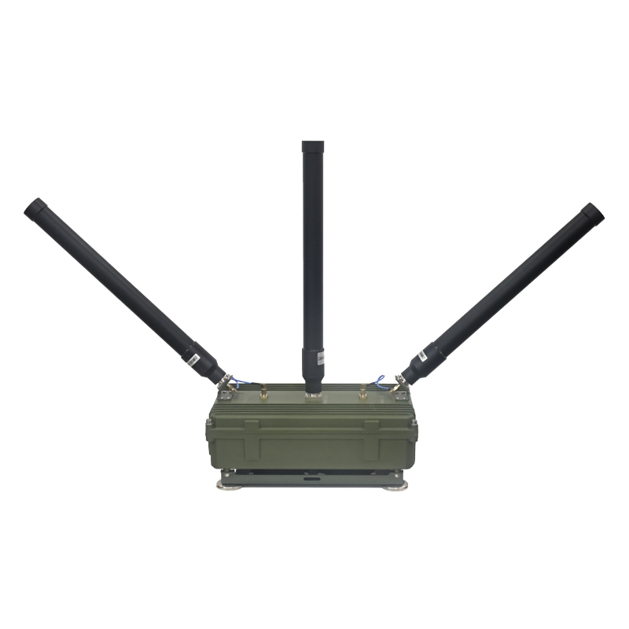
Model: TTSK07

- Product Features:
- Efficient Jamming: Uses advanced signal jamming technology to transmit interference signals on the same frequency bands as FPV drones, effectively disrupting communication and navigation, causing the drone to lose control or malfunction.
- Vehicle-Mounted Design: Magnetic mount with four ultra-strong magnets for easy placement on car roofs; supports DC 24V power supply from vehicle or mobile power source; one-button activation; capable of countering drones while in motion.
- Multi-Frequency Coverage: Customizable frequency bands available per customer requirements.
- Full Aluminum Housing: Equipped with high-power external cooling fans for excellent heat dissipation and stable operation.
- 45-Degree Antenna Layout: Designed to eliminate blind spots of omnidirectional antennas, improving jamming effectiveness.

Technical Specifications:
Specification | Details
Frequency Bands | 100–400 MHz / 400–700 MHz / 700–1000 MHz (customizable)
Total RF Output Power | 150W (50W per module)
Number of Jamming Modules | 3
Protection System | Over-temperature protection
Antenna Type | Omnidirectional antennas
Number of Antennas | 3
Device Dimensions | 320 × 190 × 120 mm
System Weight | Approx. 4 kg
Operating Temperature | -30°C ~ +70°C
Power Supply | 24V cigarette lighter (DC 24–32V)

- Accessories:
Main Unit ×1
Omnidirectional Antennas ×3
24V Cigarette Lighter Power Cable ×1
